**Ownership Transfer Basics**

The purpose of a deed is to transfer ownership of a property from one party to another.

A deed must contain each of the following items in order to be considered valid:

* *Grantor(s) – the person selling/gifting*
* *Grantee(s) – the person buying/receiving*
* *Parcel Number*
* *Legal Description*
* *Sale Date*
* *Notary Seal*
* *Signatures of each grantor or their authorized representatives*

If these items are missing, or if there are errors in spelling (for example, if the owner’s name appears of record as ‘Bill Spencer’ and the deed says ‘Bill Specner’) or if the legal description does not match PACS, the document cannot be processed. Before asking a taxpayer to re-record a deed, it is best to verify that the mismatched information is not due to clerical error.

***To correct an error on a deed, the document must be re-notarized and re-recorded.*** Corrections cannot be made in or submitted to our office, as this invalidates the notary seal. It is the responsibility of the party who recorded the original document to make corrections and re-record with the Auditor’s Office.

**ASSESSOR RECORDS ARE FOR TAX PURPOSES ONLY.** The Assessor’s Office does not have legal bearing over title. Questions regarding title history or the preparation of a deed constitute legal advice, and taxpayers should be advised to consult a title company or attorney. We cannot make specific recommendations or referrals, and we cannot assist anyone in the preparation or alteration of documents.

**Key Ownership Transfer Terms**

**Deed:** A deed is a legal document signed by the person or persons conveying interest in a piece of property. The identity of the signor(s) is witnessed and verified by an authorized person such as a notary. A deed is the physical representation of a sale or ownership transfer. Information on state requirements, limitations, and expectations for property conveyances can be found under Washington State RCW Chapter 64.

**Property ID or PID:** 5-6 digit number used to identify a property in PACS. This is usually the simplest and most direct way to reference a property, but it is not required information on a deed.

**Parcel Number or Geo Number:** 15-digit number used to identify the geographic location of a property. Should always appear on a deed in addition to the legal description.

**REET:** Real Estate Excise Tax is collected by the Treasurer’s Office upon the sale/transfer of a property. This term may be also used informally to refer to a real estate excise tax affidavit. An excise tax affidavit contains details about the sale of a property including sale price, assessed value, owners’ names, addresses, etc.

**Excise Number:** 6-digit number assigned by the Treasurer’s Office. Usually appears toward the top/center of a deed and at the top of an excise tax affidavit. This is the number you will reference under ‘Deeds & Sales’ in PACS when processing an ownership transfer.

**Grantor:** Seller

**Grantee:** Buyer

**Legal Description:** A description of a parcel of land that is so unique and adequately described that the validity of such description could be legally defended in a court of law. A complete and accurate legal description is required to transfer ownership. Inaccuracies that confuse the legal description will require correction and re-record.

**Auditor’s File Number:** 10-digit hyphenated number generated by the Auditor’s Office to reference a recorded document. The first four digits represent the year in which it was recorded. (Ex: 2020-123456)

**Recording Date:** The date a document was recorded. This accompanies the file number at the top of the document.

**Re-Record:** When changes are required, a document must be corrected, re-notarized, and re-recorded. Taxpayers should contact the Auditor’s Office for fee information.

**BLA:** Boundary Line Adjustment. Any type of change that results in an alteration of a property’s boundary line and/or size. Other terms related to a BLA include *split, merge, subdivision, short plat, and long plat*. Boundary line adjustments should be forwarded to the Segregations department. The deed technician does **not** process these.

**Vesting:** Wording that conveys a property from one party to another is known as the vesting. This should be in sentence or paragraph form and contain the grantor and grantee names. Errors in the vesting will require a re-record.

**Indexing:** Some documents may specify the grantor, grantee, parcel number, etc in list form. This indexing is for informational purposes only and cannot be substituted for vesting.

**Community Property:** Washington is a community property state. Loosely defined, this means that both spouses in a marriage or domestic partnership retain ownership rights to a property and must act together in order to sell, gift, or otherwise transfer said property. Community property is defined under RCW 26.16.030.

**Separate Property:** Spouses in a marriage or domestic partnership may elect to separate community property by conveying their interest to the other partner. Conveyances between spouses or domestic partners are defined under RCW 26.16.050.

**Multi-Parcel Sale:** This refers to a deed that transfers multiple properties in a single transaction. A ‘multi-parcel sale’ note should be placed in the comments field of PACS. This note will aid in verifying that the sale price is appropriate.

**Land & Home Bundle:** A sale price that appears exorbitantly high above assessed value may represent a land and home bundle. This means we have not yet determined an assessed value for new improvements on the land. A ‘land & home bundle; home not valued yet’ note should be placed in the comments field of PACS.

**Also Known As (AKA), Acquired Title As, Formerly Known As (FKA), or Previously Appears of Record As:** This wording is used to indicate that a grantor’s name has changed since they acquired title, usually due to marriage, divorce, or court order.

**Title:** Describes a person’s legal right to use, transfer, or convey a property. Unlike mobile homes or automobiles (which may possess a physical document called a ‘title’) this term in real property is abstract. A deed is considered the legal document which affirms title.

**To Further Assure Title:** This wording is used when a spouse or domestic partner who does not necessarily appear on previous deeds releases any potential interest they may have in a property.

**Common Documents and Ratio Codes**

**Statutory Warranty Deed or ‘SWD’ (0) / Warranty Deed (0)** Grantor has a good title to the land conveyed free and clear of undisclosed encumbrance, liens or someone having title RCW 64.04.030

**Real Estate Contract (0)** For the purpose of Assessor records, a real estate contract is treated as a standard sale, similar to a Statutory Warranty Deed.

**Quit Claim Deed or ‘QCD’** **(9)** Typically adds, removes, or corrects an owner. It is also used to create separate or community property between spouses, or when a property is given as a gift. In most cases there is no sale price. The grantor is normally conveying whatever interest they have. RCW 64.04.050

**Bargain and Sale Deed (27) / Special Warranty Deed or ‘SPWD’ (27)** Grantor also makes assurance of good title on the property. Grantors only guarantee his/her own actions will not cause any disturbance. Grantor is responsible if grantee is disturbed by some claim arising through actions of grantor. RCW 64.04.040

**Trustee’s Deed (4)**

**Sheriff’s Deed (5)**

**Lack of Probate Affidavit or ‘LOP’ (9)** Most commonly used in the case of a deceased owner whose estate has not been processed in court. A copy of an official certificate of death and a list of heirs – as well as their relationship to the deceased - should be provided. This document is used when other sources of verification (court orders, community property agreements, etc) are not available.

**Divorce Decree** Can remove a spouse or former spouse’s name from our records, provided that the decree explicitly states which spouse receives the property in the separation. The property must be clearly defined – including parcel number and legal description– and the decree must be stamped by the court.

**Transfer on Death Deed** Does not require immediate action. Until a death certificate is provided, there will be no ownership change.

**Personal Representative’s Deed / Executor’s Deed (3)** Used when a personal representative or executor is authorized to act on behalf of a deceased or legally incapacitated person. In the case of a court-appointed representative, a cause number should be provided on the deed or excise tax affidavit. In the case of appointment by will, a photocopy of an official death certificate and a photocopy of a notarized will should be provided.

**Fulfillment Deed** This document is recorded when a contract or financial agreement with a lender has been completed. It does not result in an ownership transfer unless specifically indicated. If a taxpayer calls and asks for a copy of their ‘title’, they may be referring to this type of deed, and should be transferred to the Auditor for assistance.

**Community Property Agreement or ‘CPA’** Spouses may sign a community property agreement stating that they share ownership rights to a property. Excise is not required to remove a deceased spouse when both CPA and certificate of death are present. The CPA must be notarized and recorded. These documents should be scanned and attached to an ‘Ownership Chg’ comment in PACS.

**Letters of Administration / Letters Testamentary** Documents issued by the court when a personal representative is authorized to handle another person’s estate. The county and cause number should be noted on sales involving deceased owners.

**Deed Regarding Real Property** Generally used to reference previously recorded documents. For example, if a Community Property Agreement was filed many years ago and one of the spouses is now deceased, the surviving spouse may filed a ‘deed regarding real property’ to bring attention to the change in ownership.

**Judgements** Documents that are ruled by a judge, it has to have a parcel number and legal description.

**Sample Deed:**

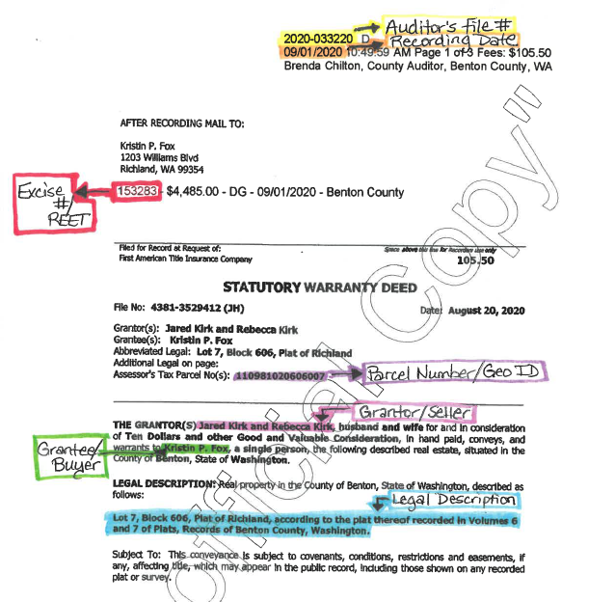

**How to Print Documents from the Auditor’s Website**

<http://chtylerapp/recorded/web/>

Scroll down and click ‘I Acknowledge’.

Using the ‘Start Date’ and ‘End Date’ boxes, enter the date(s) you wish to search.

Unclick the ‘Search All Types’ box.

Using ‘Ctrl’ and your mouse button, select each document type you would like to print. You can click a second time (still holding ‘Ctrl’) to deselect an item.

Click ‘Search’, then ‘Add All to my Images’.

Scroll down and click ‘Download My Images’, then right click and ‘Print’.

**Document types to be printed**

* Addendum
* Affidavit
* Affidavit – Lack of Probate
* Affidavit of Correction
* Cert of Death
* Community Prop Agree
* Contract
* Deed
* Dissolution
* Error Correction
* Forfeiture
* Judgment
* Lease
* Miscellaneous
* Multiple Title Documents
* Order
* Ordinance
* Purchasers Assign
* Resolution
* Sellers Assignment